**Module 2**

**(Java with oops)**

**Assignment no. 1**

**Q1 Write a program to print Hello World. Compile and run it using command prompt.**

class Hello1

{

public static void main(String args[])

{

System.out.println("HELLO");

}

}

**//Output**

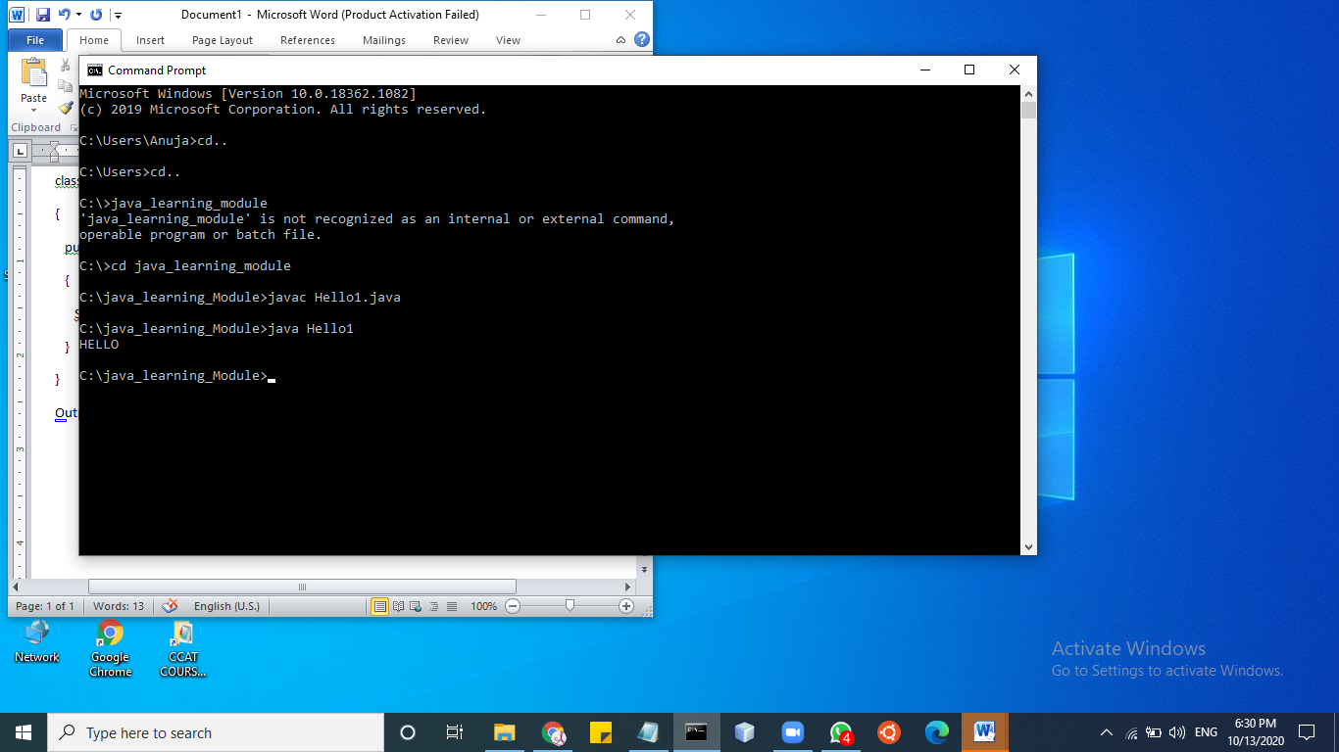

**Q2 Write a program to declare a variable named rollNo of integer type. Assign it a value (let say 100) to it and print the following statement roll no = 100 .**

class Hello1

{

public static void main (String args[])

{

int rollNo=100;

System.out.println("roll no="+rollNo);

}

}

**//Output**

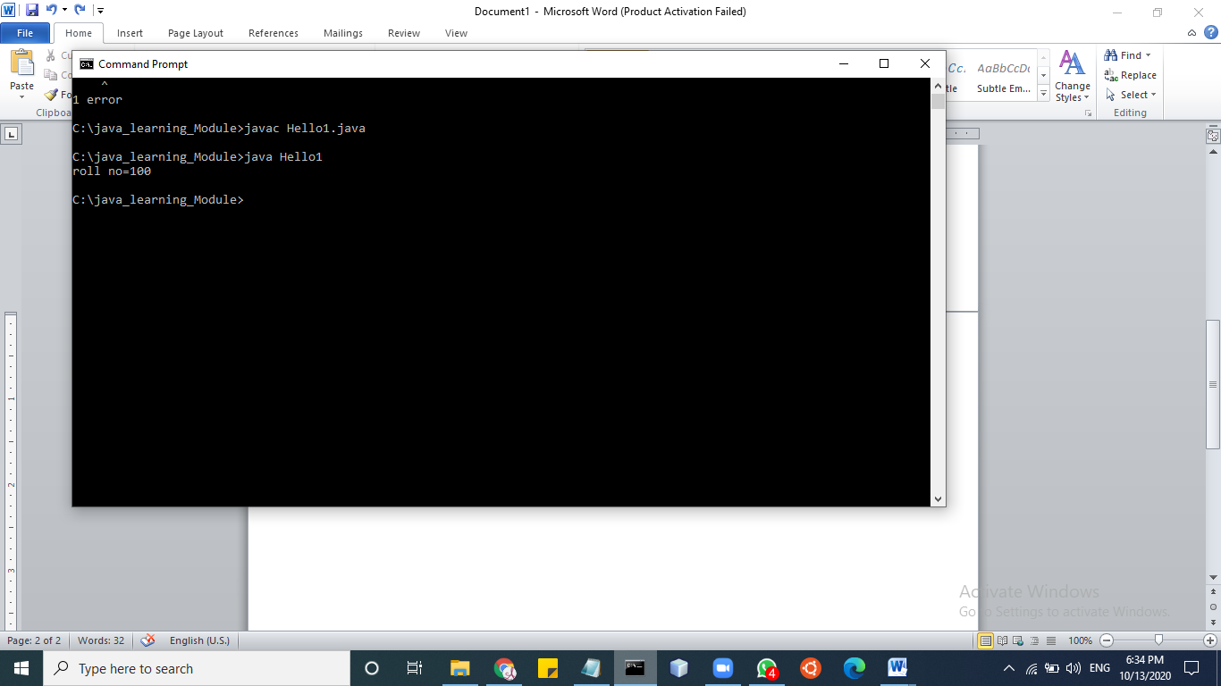

**Q3 Find the result of following expressions. You need to determine the primitive data type of the variable by looking carefully the given expression and initialize variables by any random value.**

A. y = x2 + 3x - 7 (print value of y)

B. y = x++ + ++x (print value of x and y)

C. z = x++ - --y - --x + x++ (print value of x ,y and z)

D. z = x && y || !(x || y) (print value of z) [ x, y, z are boolean variables ]

import java.util.*;

import java.io.*;

import java.lang.*;

class Hello1

{

public static void main (String args[])

{

/*System.out.println("Enter the value");

Scanner sc=new Scanner(System.in);

int x=sc.nextInt();

int y=x*x+3*x-7;

System.out.println("Y="+y);

y=x++ + ++x;

System.out.println("Y="+y);

System.out.println("X="+x);

int z=x++ - --y - --x + x++;

System.out.println("X="+x + " Y="+y + " Z="+z);*/

System.out.println("Enter the values");

Scanner sc=new Scanner(System.in);

boolean x=sc.nextBoolean();

boolean y=sc.nextBoolean();

boolean z=x && y||! (x||y);

System.out.println("Z="+z);

}

}

**//output**

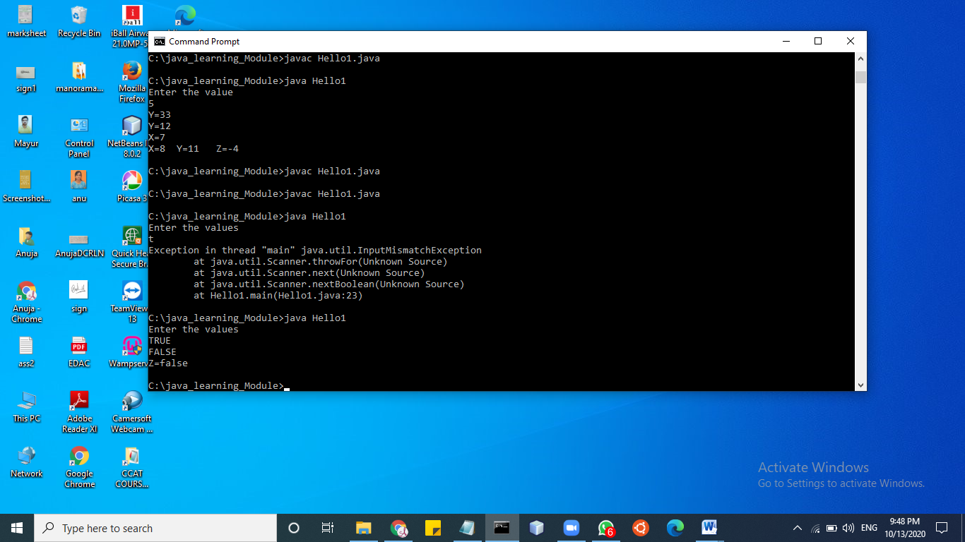

**Q4 Write a program that initializes 2 byte type of variables. Add the values of these variables and store in a byte type of variable. [Note: primitive down casting is required in this program**

import java.util.*;

import java.io.*;

import java.lang.*;

class Hello1

{

public static void main (String args[])

{

Scanner sc=new Scanner(System.in);

byte a=sc.nextByte();

byte b=sc.nextByte();

int c=(int)(a+b);

System.out.println("C="+c);

}

}

**//output**

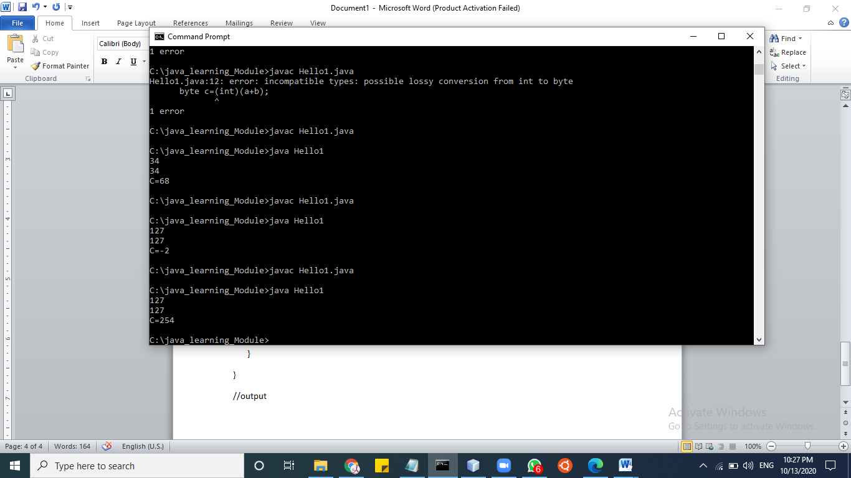

**Q5 Write a program that takes user’s name as command line argument and prints Welcome <entered user name**

import java.util.*;

import java.io.*;

import java.lang.*;

class Hello1

{

public static void main (String args[])

{

String a=args[0];

System.out.println(“ welcome”+a);

}

}

**//output**

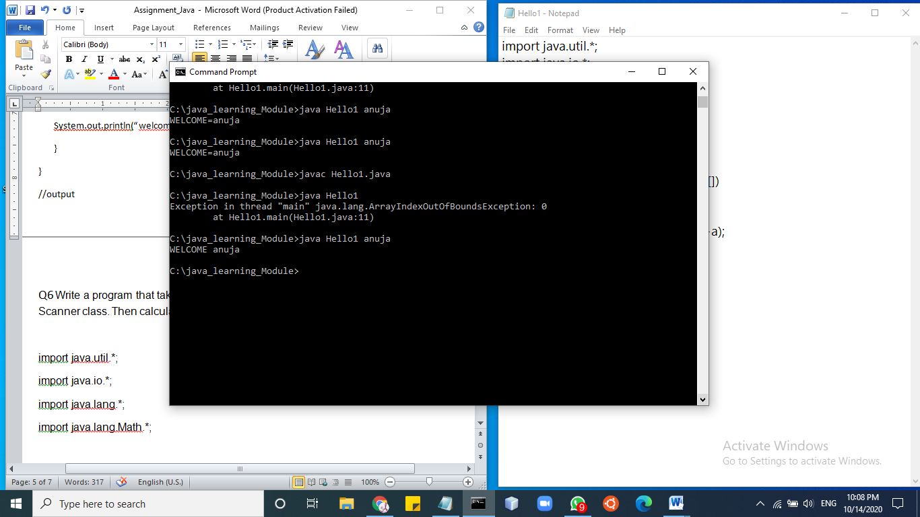

**Q6 Write a program that takes radius of a circle as input. Read the entered radius using Scanner class. Then calculate and print the area and circumference of the circle.**

import java.util.*;

import java.io.*;

import java.lang.*;

import java.lang.Math.*;

class Hello1

{

public static void main (String args[])

{

System.out.println("Enter the radious");

Scanner sc=new Scanner(System.in);

long x=sc.nextLong();

double a=Math.PI*x*x;

double c=2*Math.PI*x;

System.out.printf("Circumference : %.3f", c);

System.out.printf(" Area : %.3f", a);

}

}

**//output**

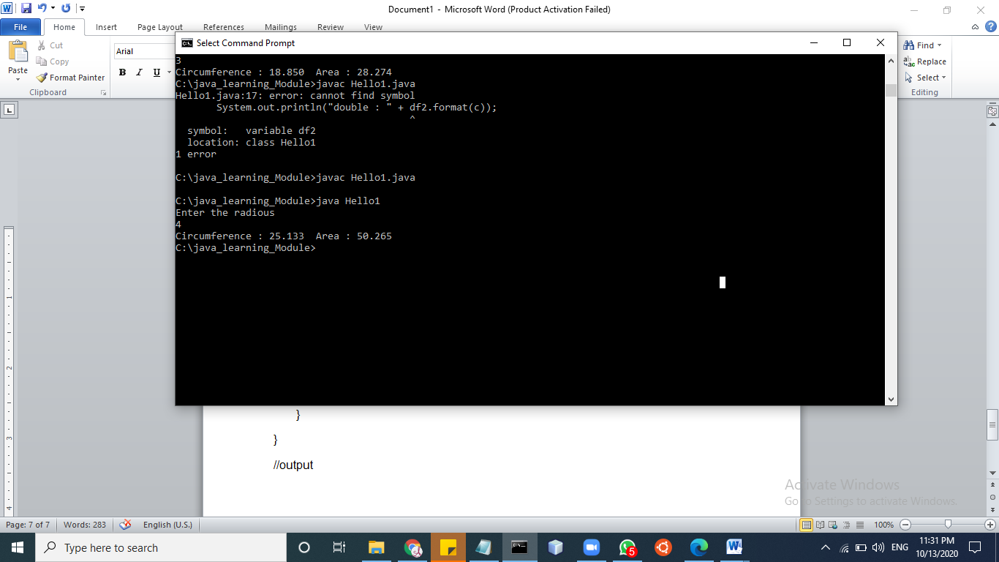

**Q7 Write a program to calculate sum of 5 subject’s marks & find percentage. Take the obtained marks from user using Scanner class. Output should be in this format [ percentage marks = 99 % ] Use concatenation operator here.**

class Hello1

{

public static void main (String args[])

{

Scanner sc=new Scanner(System.in);

int arr[ ]=new int[5];

float total=0;

float per;

System.out.println("Enter 5 sub marks");

for(int i=0;i<5;i++)

{

arr[i]=sc.nextInt();

}

for(int i=0;i<5;i++)

{

total=total+arr[i];

}

System.out.println("Sum="+total);

per=(total/500)*100;

System.out.println("PERCENTAGE="+per+"%");

}

}

**//output**

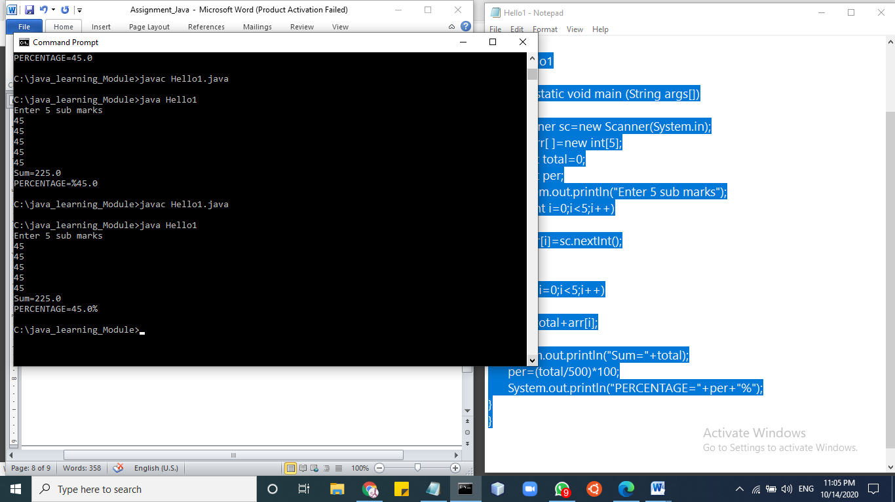

**Q8 Write a program to find the simple interest. Take the principle amount, rate of interest and time from user using Scanner class.**

import java.util.*;

import java.io.*;

import java.lang.*;

import java.lang.Math.*;

class Hello1

{

public static void main(String args[])

{

float p, r, t, sinterest;

Scanner scan = new Scanner(System.in);

System.out.print("Enter the Principal : ");

p = scan.nextFloat();

System.out.print("Enter the Rate of interest : ");

r = scan.nextFloat();

System.out.print("Enter the Time period : ");

t = scan.nextFloat();

scan.close();

sinterest = (p * r * t) / 100;

System.out.print("Simple Interest is: " +sinterest);

}

}

**//Output**

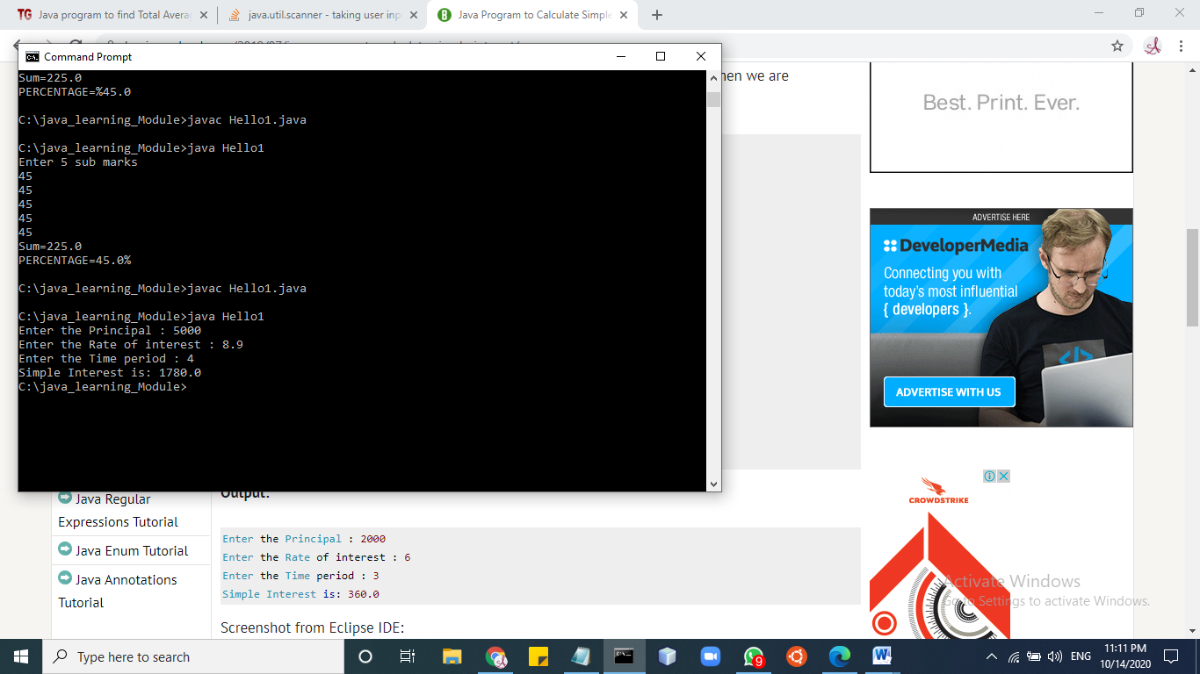

**Q13 Program to find greatest in 3 numbers. [ once using if else statement and then using ternary operator ( logical operator) ]**

import java.util.*;

import java.io.*;

import java.lang.*;

import java.lang.Math.*;

class Hello1

{

public static void main(String[] args)

{

/* int x, y, z, temp,result;

Scanner sc= new Scanner(System.in);

System.out.println("Enter First Number:");

x = sc.nextInt();

System.out.println("Enter Second Number:");

y = sc.nextInt();

System.out.println("Enter Third Number:");

z = sc.nextInt();

sc.close();

temp = x>y? x:y;

result = z>temp ? z : temp;

System.out.println("Largest no.="+result);*/

/* Scanner sc=new Scanner(System.in);

System.out.println("Enter any 3 values");

double a=sc.nextInt();

double b=sc.nextInt();

double c=sc.nextInt();

if(a>=b && a>=c)

System.out.println(a+" is greatest");

else if(b>=a && b>=c)

System.out.println(b+" is greatest");

else

System.out.println(c+" is greatest");*/

Scanner sc=new Scanner(System.in);

System.out.println("Enter any 3 values");

double a=sc.nextInt();

double b=sc.nextInt();

double c=sc.nextInt();

if(a>b)

{

if(a>c)

System.out.println(a+" is greatest");

else

System.out.println(c+" is greatest");

}

else

{

if(b>c)

System.out.println(b+"is greatest");

else

System.out.println(c+"is greatest");

}

}

}

**//output**

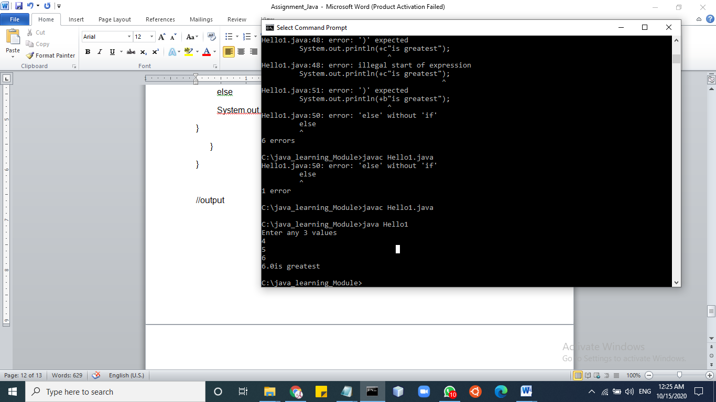

**Q9 Write a program to read the days (eg. 670 days) as integer value using Scanner class. Now convert the entered days into complete years, months and days and print them.**

class Hello

{

public static void main(String args[])

{

int m, year, week, day,months;

Scanner s = new Scanner(System.in);

System.out.print("Enter the number of days:");

m = s.nextInt();

year = m / 365;

m = m % 365;

System.out.println("No. of years:"+year);

months=m/30;

m=m%30;

System.out.println("No. of months"+months);

week = m / 7;

m = m % 7;

System.out.println("No. of weeks:"+week);

day = m;

System.out.println("No. of days:"+day);

}

}

**//OUTPUT**

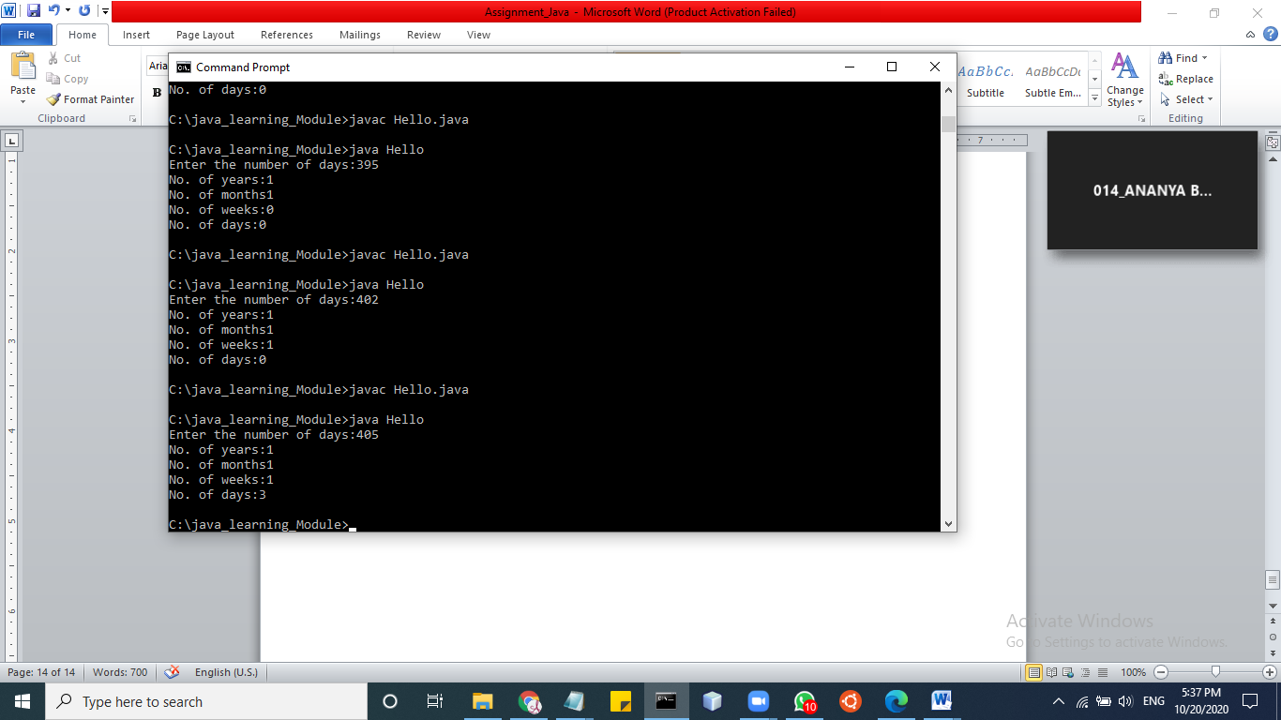

**Q10 Write a program to convert temperature from Fahrenheit to Celsius. Take Fahrenheit as input using Scanner class. [ formula : C= 5*(f-32)/9 ]**

import java.util.Scanner;

class Hello

{

public static void main(String args[])

{

System.out.println("Enter temp");

Scanner sc=new Scanner(System.in);

double f=sc.nextDouble();

double c=5*(f-32)/9;

System.out.println("Celeius="+c);

}

}

**//OUTPUT**

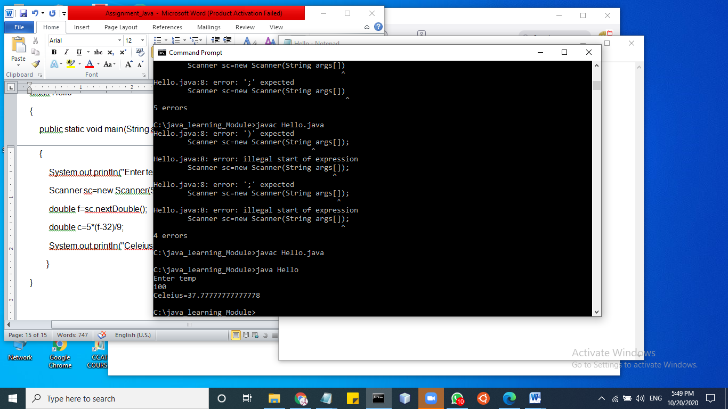

**Q11 Write a program to swap two numbers without using third variable.**

import java.util.Scanner;

class Hello

{

public static void main(String args[])

{

System.out.println("Enter the values");

Scanner sc=new Scanner(System.in);

int a,b=sc.nextInt();

int b=sc.nextInt();

int temp;

System.out.println("Before swapping "+ a +" "+ b);

temp=a;

a=b;

b=temp;

System.out.println("After swapping "+ a+" "+ b);

}

}

//Output

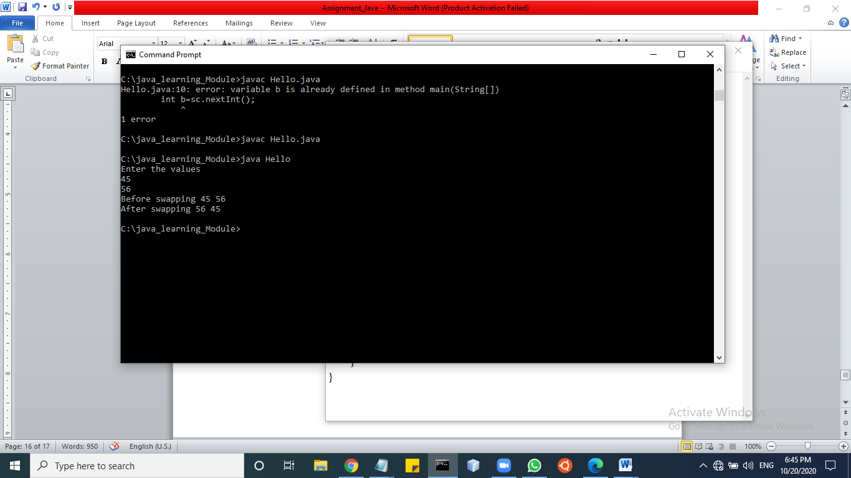

**Q12 In a company an employee is paid as under: If his basic salary is less than Rs. 10000, then HRA = 10% of basic salary and DA = 90% of basic salary. If his salary is either equal to or above Rs. 10000, then HRA = Rs. 2000 and DA = 98% of basic salary. If the employee's salary is input by the user write a program to find his gross salary. [ formula : GS= Basic + DA + HRA ]**

import java.util.Scanner;

class Hello

{

public static void main(String args[])

{

System.out.println("Enter ur basic salary");

Scanner sc=new Scanner(System.in);

float bs=sc.nextFloat();

float HRA,GS,DA;

if(bs<10000){

HRA=(10*bs)/100;

DA=(90*bs)/100;

}

else{

HRA=2000;

DA=(98*bs)/100;

}

GS=HRA+DA+bs;

System.out.println("Your gross salary= "+GS);

}

}

//output

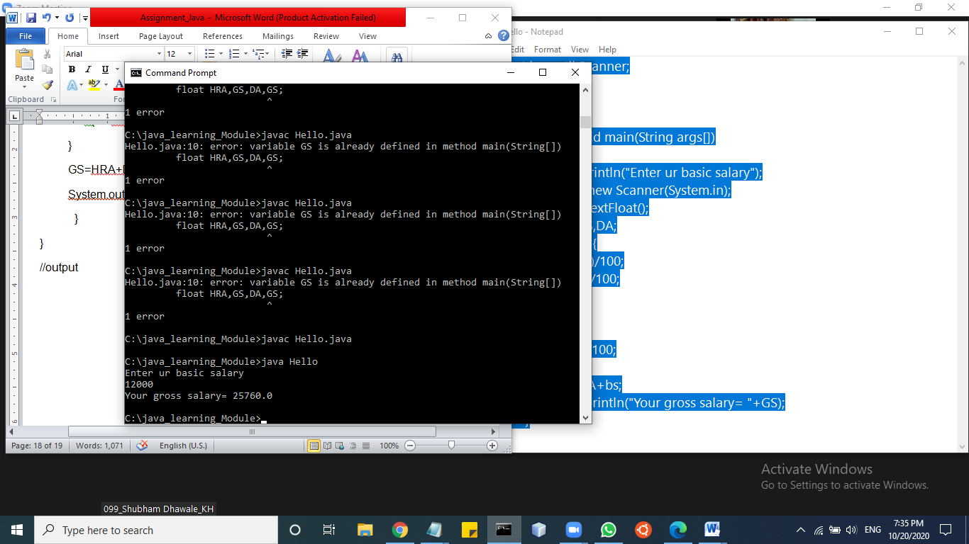

**Q13 Program to check that entered year is a leap year or not.**

**import java.util.Scanner;**

class Hello

{

public static void main(String args[])

{

Scanner sc=new Scanner(System.in);

int year=sc.nextInt();

boolean leap = false;

if(year % 4 == 0)

{

if( year % 100 == 0)

{

if ( year % 400 == 0)

leap = true;

else

leap = false;

}

else

leap = true;

}

else

leap = false;

if(leap)

System.out.println(year + " is a leap year.");

else

System.out.println(year + " is not a leap year.");

}

}

**//Output**

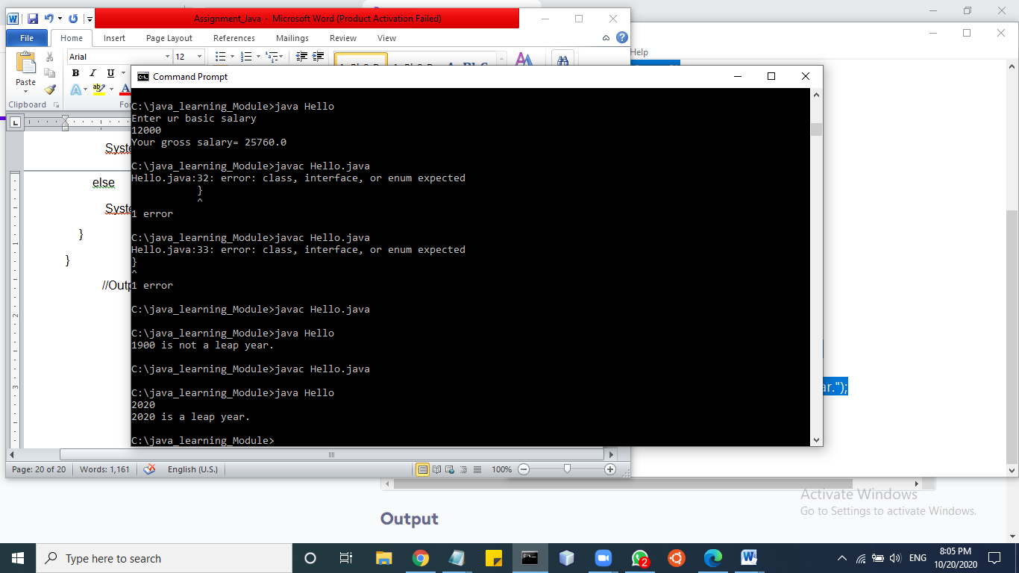

**Q14 Accept person’s gender (character m for male and f for female), age (integer), as input and then check whether person is eligible for marriage or not.**

import java.util.Scanner;

class Hello

{

public static void main(String args[])

{

Scanner sc=new Scanner(System.in);

int year=sc.nextInt();

boolean leap = false;

if(year % 4 == 0)

{

if( year % 100 == 0)

{

if ( year % 400 == 0)

leap = true;

else

leap = false;

}

else

leap = true;

}

else

leap = false;

if(leap)

System.out.println(year + " is a leap year.");

else

System.out.println(year + " is not a leap year.");

}

}

**//Output**

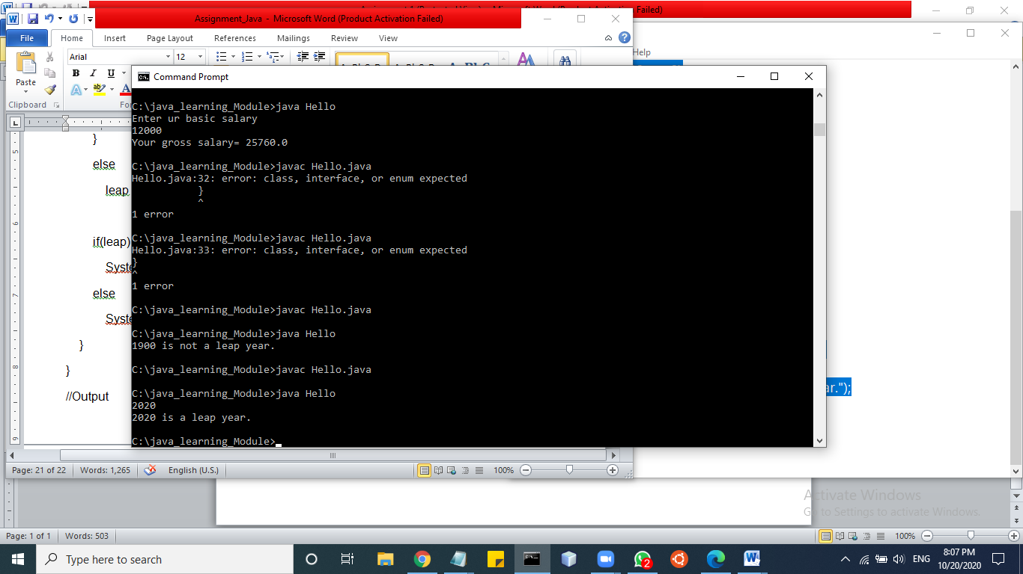

**Q15 Accept person’s gender (character m for male and f for female), age (integer), as input and then check whether person is eligible for marriage or not.**

import java.util.Scanner;

class Hello

{

public static void main(String args[])

{

Scanner sc=new Scanner(System.in);

System.out.println("Enter gender: M/F");

int gen=sc.next().charAt(0);

System.out.println("Enter age:");

int age=sc.nextInt();

if(gen=='M'){

if(age>25){

System.out.println("Yes Eligible");

}

else{

System.out.println("Not Eligible");

}

}

else{

if(gen=='F'){

if(age>21){

System.out.println("yes Eligible");

}

else{

System.out.println("Not Eligible");

}

}

}

**//Output**

